Student Climate Change Research: Challenges and Opportunities
David R. Brooks, PhD
President, Institute for Earth Science Research and Education
Asia-Pacific GLOBE Learning Expedition
Hua Hin, Thailand, November 13-18, 2007

Abstract

Understanding global climate is one of the major science and policy challenges for the 21st century. The consequences of climate change, whatever its cause, will affect everyone on the planet in one way or another. Today’s students will, as adults, inhabit a world that, in dramatic or subtle ways, will be different from the present world. Geoscience teaches students about climate and how it is changing. Can students also contribute to climate change science?
I believe the answer to this question is, and must be, “Yes!” Weather and climate science depend critically on observations and measurements. Hence, true understanding of how the Earth/atmosphere system works requires active involvement in authentic hands-on science activities. However, there is a huge difference between being well-informed about climate and making real contributions to climate change research. This paper addresses some of the opportunities and challenges facing everyone who believes in the value of forming partnerships among students, teachers, and scientists that will enable students to make real contributions to science. Some examples are given of “professional” data of questionable value, and of some student-generated data that have the potential to make real contributions to climate science.

1. Introduction

Global climate change is one of the most important science and public policy challenges for the 21st century. Despite some disagreements about details, the vast majority of Earth scientists believe that global climate change is already occurring at a much faster rate than in the recorded historical past, and that human activity is responsible for much of this change, primarily through the rapid increase in the consumption of fossil fuels. As a result, today’s students will, as adults, inhabit a 21st century world that in some places will be much different from the present world.
If this scenario is true, what is the role of education? Can students and their teachers promote a better understanding of climate—what controls it and how it is changing? How should students and teachers respond to the reality that some of the projected climate changes are already “set in place” and cannot be reversed? Is it enough just for science education to teach students the relevant facts and help them understand the issues, or does authentic education require the immersion of students and their teachers in authentic science activities? Is it possible for these activities to make a real contribution to climate science? If it is possible, does this represent a reasonable goal for education that is worth the extra effort to achieve?

What Is Climate?
“Climate” refers to average meteorological conditions. When applied to a particular place or region, climate is often based on 30-year averages of meteorological conditions. In this sense, climate is related to weather, but it is not the same thing. “Climate is what you expect. Weather is what you get.” [Robert Heinlein, 1973]
Weather includes short-term fluctuations in meteorological conditions, driven by seasons and movements of air. Weather may sometimes appear random, but it is not. Although meteorological details can be predicted accurately only over a few days, fluctuations in weather “ride” on top of climate. In temperate climates, it is predictably colder in the winter than in the summer. In southeast Asia, monsoon cycles are reasonably predictable.
Here is an example of a regional climate:

Thailand has a tropical climate with high temperatures and relative humidity. It is dominated by the monsoon cycle. April and May are the hottest months. June is the start of the monsoon, which brings a rainy season that lasts through October. Temperatures are somewhat cooler in November through February, with lower humidity and northeast breezes. The north and northeast are generally cooler than Bangkok between November and February, and hotter in summer. Temperatures in Thailand never fall below freezing (0°C).

Regional climate changes are already known to be occurring. In 2007, the summer Arctic ice cap shrank to a record low area [National Snow and Ice Data Center, 2007]. Glaciers are retreating in much of the world. These changes are occurring very rapidly by historical standards and, in some cases, much more rapidly than predicted by scientists only a few years ago.
“Climate” also refers to average global conditions over much longer spans of time—thousands of years and longer. Global climate change means that average conditions on Earth are changing. In general, the global climate appears to be getting warmer. Although no one disputes that the Earth will eventually experience another ice age, as it has several times in the past, the global warming that is now underway will cause dramatic disruptions in the environment and in human societies in the relatively near future unless it can be controlled.
Our knowledge of climate conditions over Earth’s entire lifetime cannot, of course, be based on recorded historical observations. However, ancient climates can be inferred from several sources. One famous source is the Vostok Station ice core record from eastern Antarctica, collected in the 1970’s. Figure 1 shows dust trapped in the core, CO₂ concentrations as measured in trapped air bubbles, and relative temperature that is inferred from the ratio of two isotopes of oxygen (O₁₈/O₁₆).
In Figure 1, it is clear that CO₂ and temperature are positively correlated, but which is the cause and which is the effect? It is not possible to tell just from these data, but because of the well known greenhouse effect, most scientists believe that increasing levels of CO₂ are the cause of warming global temperatures. The cause-and-effect relationship between dust and temperature is less clear, but increased levels of dust are clearly associated with colder (and drier) global conditions.
There are other proxy measurements for temperature, including sediment cores. Figure 2 shows a graph of temperature since the end of the last ice age, about 11,000 years ago, relative to mid 20th century global temperatures. Recent global temperatures have risen rapidly compared to previous rates of change and are significantly higher than at any time since the end of the last glacial period.

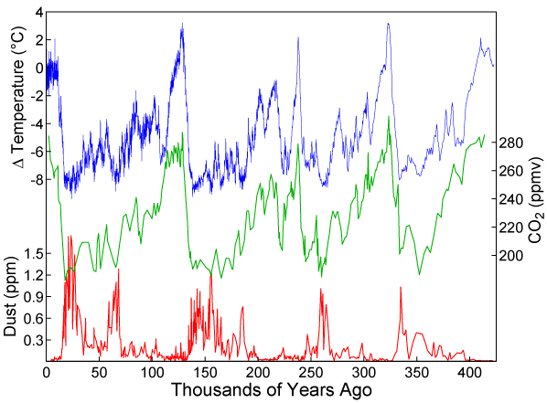
Figure 1. Global climate conditions inferred from Antarctic ice cores [Petit et al., 1999].

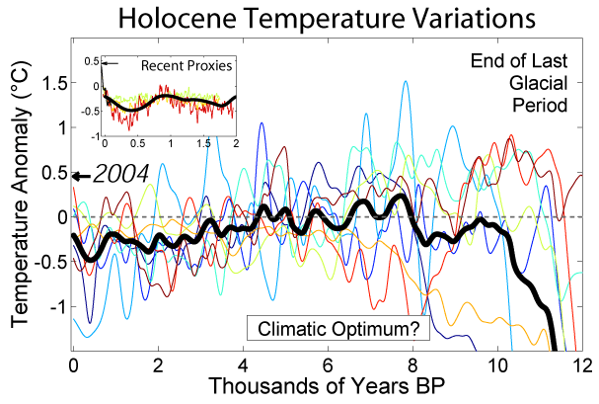
Figure 2. Global temperature variation since the end of the last glacial period [Rohde, online 2007].

Closer to the present, Figure 3 shows the relationship between CO₂ and global temperature since the start of the Industrial Revolution (and the rapidly rising use of fossil fuels associated with that revolution). These values are directly measured. Although this relationship does not “prove” that rising CO₂ causes rising temperatures, scientists’ understanding of the greenhouse effect leads inevitably to the conclusion that CO₂ injected into the atmosphere as a consequence of the dramatic increase in fossil fuel consumption is, in fact, the major cause of the observed increase in global temperature starting in the late 19th century. There is evidence that other factors are at work, too, including increasing deposition of carbon soot on the vast areas of snow-and ice covered land and oceans in the northern hemisphere. But these factors, too, are a result of increasing fossil fuel consumption and other industrial activity.

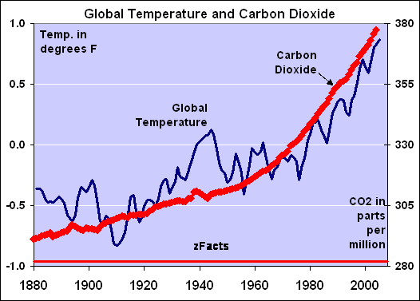
Figure 3. Global CO₂ and temperature [zfacts.com, 2007].

What are the consequences of these kinds of changes? In southeast Asia:

- Sea level may rise 20 cm by 2030. Much of Bangkok and its surroundings are within 1 m of present sea level. Valuable coastal farmland will be lost. Disappearance of beaches will decrease tourism.
- There may be reduced rice production due to loss of land, higher temperatures, and changing rainfall patterns.
- There will be social consequences if farmers and fishermen cannot adapt to changing conditions. Spontaneous migration of large populations could be financially disruptive and create more serious environmental problems.
[Excerpted from Northern Territory University, Australia, online 2007]

In coastal areas around the world, rising sea levels are a major concern because of the concentration of human populations along coasts. Other parts of the world will face different challenges, including changing and possibly more severe weather patterns, disruption of agriculture, loss of plant and animal species unable to migrate or adapt to changing conditions, and increasing exposure to vector-borne diseases such as malaria.

What Can We Do About Climate Change?
Especially for students, it is important not to over-emphasize the grim predictions about inevitable climate change. There are, in fact, many things that all citizens can do to prepare for climate changes and even to minimize those changes. These include:

- Quantify indicators of climate change.
- Attempt to understand what kinds of human activities are contributing to climate change and minimize those activities.
- Make responsible personal and community choices about how we use energy.
- Hold our governments responsible for investing in and implementing policies that protect the environment, including moving away from a fossil fuel-based economy.

Some of these activities require determined action by informed citizens, which requires education about climate and climate change. Quantifying climate change indicators and understanding how climate works is a scientific undertaking that goes beyond “just” education. The two important questions in this regard are:

1. Can students contribute to climate change research?
2. Should students contribute to climate change research?

I am confident that the answer to the first of these questions is “Yes!” Earth science, more than some other areas of science, is still strongly dependent on observations and measurements around the globe. There are quantities that should be measured much more frequently, and in many more places, than they are. Of course, some of these measurements require expensive and specialized equipment, but there are still many measurements students can make that could contribute significantly to our understanding of Earth’s climate.
The answer to the second question is less clear. It is one thing to ask whether students and teachers can do authentic science, but it is more complicated to decide whether it is worth the investment of time, resources, and money to do so. I do not question that it is possible to have a high-quality science education program that does not require high-quality long-term student/teacher research. However, my personal opinion is that science education separated from the process of authentic research experiences gives students a distorted and limited picture of what science is about. I believe that exposure to such experiences is required in order to inspire students to pursue careers in science and to become active participants in the climate change debate taking place in the 21st century.

2. What Are the Requirements for Student Climate Research?

There are some general guidelines for conducting meaningful student research:

- Understand the problems and ask the right questions.
- Form partnerships among scientists, teachers, and students, and their institutions.
- Make long-term institutional commitments that do not depend just on individuals.
- Make the equipment investments required to produce high-quality data. (Sometimes these investments can be small!)
- Follow international standards for data collection.
- Use automated data collection whenever appropriate.
- Make a commitment to long-term data quality.

The first step in successful student research is to understand the research problems
and ask the right questions. It is important to direct student activities along paths that will yield useful results, and it is important to be honest about the value of specific activities. There are many activities that are interesting, challenging, and serve a legitimate educational purpose. These may or may not contribute to climate science in any meaningful way. This does not mean that such activities should not be undertaken, but only that their ultimate purpose needs to be defined.
It is not possible for schools, and their teachers and students, to undertake authentic science on their own, no matter what the field. It is also not possible for scientists simply to expect schools to “help” them with research without consulting with teachers and students themselves. Each of these groups has its own requirements and brings different skills to the project. Hence, it is absolutely necessary for all participants—students, teachers, and scientists—to form working partnerships among themselves and their institutions.
By its very nature, climate science requires a long-term view and, therefore, requires long-term commitments. Often, successful student/teacher/scientist partnerships are based on the efforts of a few committed individuals. These are admirable undertakings, but climate science requires something more. I believe that these kinds of projects will be successful only when institutions make commitments. When universities, government institutions, schools, and other organizations undertake projects, they may initially be the result of individual actions. But, they are successful over the long term only when the institutional commitment transcends individual commitments.
For any project to detect small changes over long periods of time, it is necessary to make the human and hardware investments required to produce high-quality data. These investments may go far beyond what is required for a high-quality educational experience. For example, carefully calibrated manual thermometers used according to the GLOBE air temperature protocol can yield reliable data about weather and seasonal variability. However, a very large investment of time and personal energy is required to build a continuous long-term manually collected record of daily maximum and minimum temperatures, for example. These measurements will be more successful when data collection is automated and individual efforts are directed toward quality control, calibration, and analysis. The initial investment may be more than would be required for equipment intended primarily for educational use, but this investment will return dividends in the form of higher quality data over the long term.
For any kind of measurement, it is necessary to determine whether there are international or generally accepted standards and protocols for data collection and to follow those standards even when they extend beyond educational requirements. In many cases these standards require automated data collection. For example, it is possible learn a great deal about the sun by manually recording solar energy at Earth’s surface every day near solar noon, but continuously logged measurements are required to monitor and explain long-term changes in solar radiation patterns.
Climate research requires a long-term commitment to high-quality data, perhaps extending far beyond what is required for high-quality science education. Educational institutions considering supporting student climate change research need to decide whether this extra effort is worth the investment.

Case Studies: How Not to Study Climate Changes
It is tempting to conclude that “real scientists” understand the requirements described in the previous section and are careful to meet them. Unfortunately, this is not necessarily true!
Figure 4 shows a weather station installed in a parking lot (!) at a prominent research university in the United States. It is an “official” National Weather Service station used for climate research. However, the site conditions at this station are very far from meeting international standards! The Stevenson screen is obviously seriously in need of replacement, but observers have reported that it contains no equipment—the “high quality” equipment is located outside the screen.

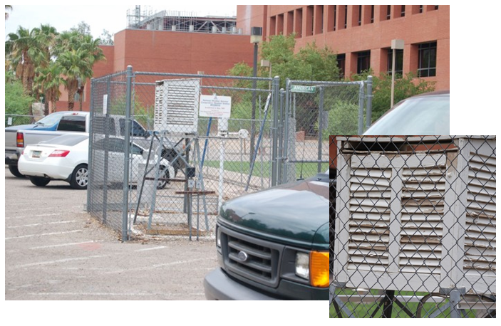
Figure 4. Poorly sited “official” weather station at the University of Arizona (See http://gallery.surfacestations.org/main.php?g2_itemId=1606)

This station has been the subject of intense criticism and even ridicule in online forums dealing with climate change research. Scientists at the university have attempted to justify the location by claiming that they are interested only in “relative” changes in temperature. But, when researchers collect temperature data from around the country or the world, they must make decisions about how to treat data from sub-standard stations. Who will make decisions about this station? What will they decide to do with its data? Does it represent “urban” conditions? Does it represent “desert” conditions that surround this university? If it is treated as an urban station, how does this relate to the climate in this part of the United States?
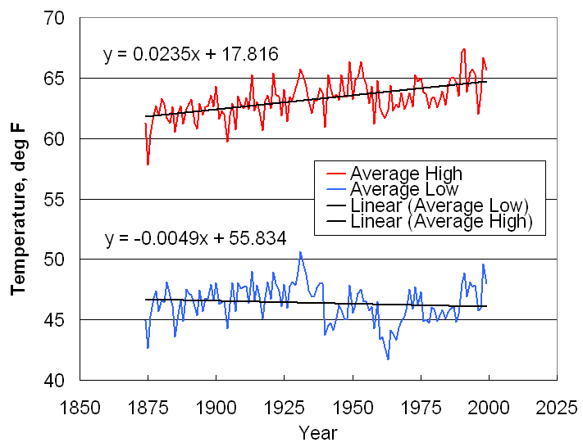
Figure 5(a). “Official” Philadelphia temperature records [www.fi.edu/weather].
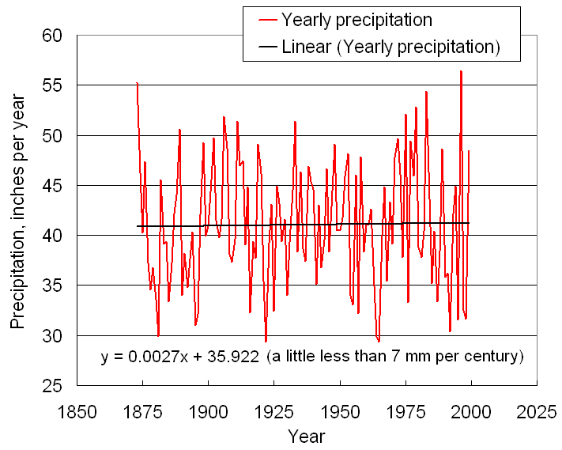
Figure 5(b). “Official” Philadelphia precipitation records [www.fi.edu/weather].
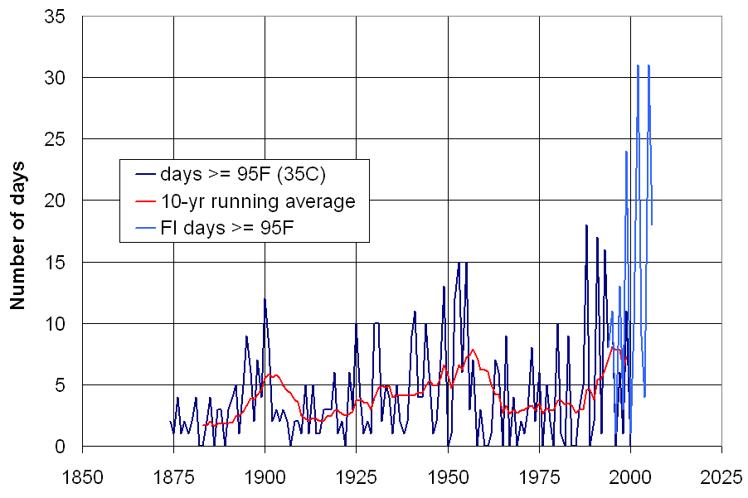
Figure 5(c). Calculated number of days above 95°F (35°C) based on Philadelphia and Franklin Institute temperatures.
Figure 5. Temperature and precipitation records from Philadelphia.
There are often hidden problems with accepting data even from “reliable” sources. Figure 5 shows some long-term meteorological data from Philadelphia, Pennsylvania, near where I live. This is a temperate climate with large seasonal variability in temperature. The high and low average temperature and precipitation data come from the “official” Philadelphia temperature record, which extends back to about 1875. (Temperatures are given in degrees Fahrenheit because that is how temperatures have always been recorded in the United States.)
The data in Figure 5(b) indicated that there is no appreciable trend in precipitation, but Figure 5(a) shows long-term changes especially in the average maximum daytime temperature. Figure 5(c) shows an even more dramatic trend. These data use official Philadelphia temperatures along with temperature data available online from The Franklin Institute. This is a highly respected science and educational institution that has been in Philadelphia for many years. Figure 5(c) shows the number of days per year with maximum daytime temperatures exceeding 95°F (35°C). Starting in the late 1990’s there is a truly dramatic increase in this value, with two years in which there were more than 30 such days! What should we conclude from these data? Is Philadelphia really undergoing a dramatic climate warming?
It is simply not true that there are this many days in Philadelphia when the maximum daytime temperature exceeds 95°F, and it is unlikely that the temperature in and around Philadelphia has really increased by nearly 3°F since the late 19th century. Are there problem with these data? To answer this question, we need to consider the source of the data. During the more than 130 years of the Philadelphia temperature record, the “official” station has moved many times and Philadelphia has grown dramatically to become (as of 2000) the United States’ 5th most populous city, with about 1,500,000 residents. For about 50 years the official station has been at the Philadelphia International Airport, close to the city and now one of the busiest airports in the world. Clearly, there is an excellent argument to be made that the temperature increases present in Figure 5 are the result of the well known urban heat island effect, and have little to do with the actual regional climate in this area.
The count of very hot days is even more of a problem for our climate. Figure 6 shows a comparison between official Philadelphia temperatures and temperatures at the Franklin Institute.

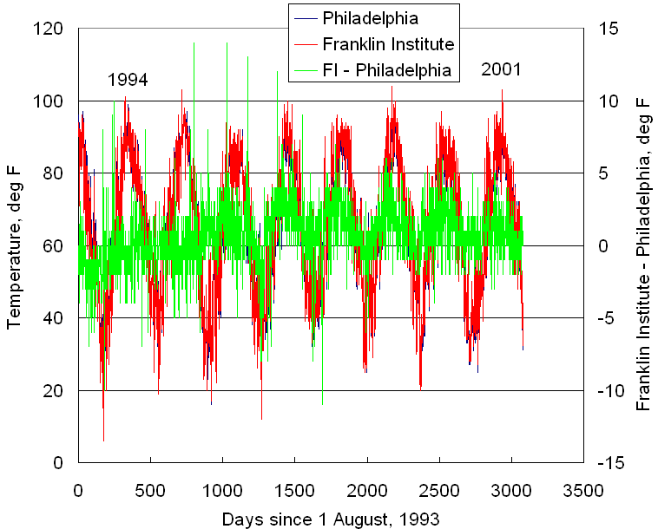
Figure 6. Comparison between Philadelphia and Franklin Institute Temperatures.

The data make clear that there is a significant difference between these two air temperature sources. Typically, temperatures at the Franklin Institute are colder in the winter and warmer in the summer than the official Philadelphia temperatures. Starting in 1996, there was a significant (but undocumented) change at the Franklin Institute weather station. Now, summertime maximum temperatures are about 5°F warmer than the temperatures at the airport. By climatological standards, this is a huge difference! The problem is that the Franklin Institute weather station is on the roof of a building in downtown Philadelphia. This is simply not an acceptable place for a weather station and, once again, this is a site that egregiously violates internationally accepted standards for locating weather stations.
What about the GLOBE Program’s thermometer enclosure? Figure 7 shows two thermometer housings—a standard Stevenson screen and the much smaller enclosure specified for GLOBE’s air temperature protocol. The larger enclosure provides more room for air flow and there is a double roof for air flow to minimize heating of the top of the shelter. This is one example where some extra investment might be required to ensure the highest quality air temperature data. Does the GLOBE enclosure lead to higher temperatures? I am unaware of studies that would provide a definitive answer to this question.

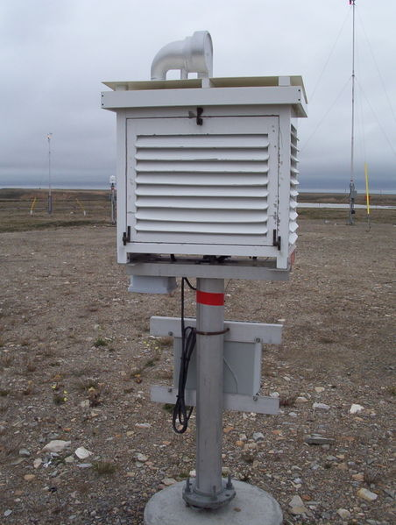 | 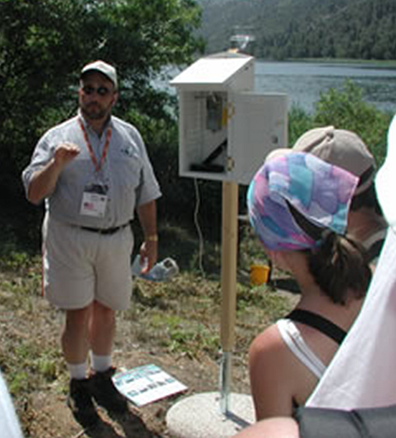
Figure 7. Comparison between standard Stevenson screen and GLOBE thermometer enclosure.

Figure 8 shows another interesting set of data—temperature and precipitation data for several cities in Thailand. These data are from a commercial Web site and they are not presented as meeting scientific standards. However, from the point of view of research conducted by students, who tend to believe that anything posted on the Web must be true, these data raise interesting questions. Figure 8(a) shows monthly average temperatures. They seem reasonable, with Bangkok being the warmest location—as might be expected because of the urban heat island effect.
However, the monthly average number of days with rain shown in Figure 8(b) seems inconsistent. Why are some of these values so different in Bangkok? What is the source of these data, and can they be trusted? I do not know the answer to these questions, but these seem like data that should be viewed with a great deal of skepticism!

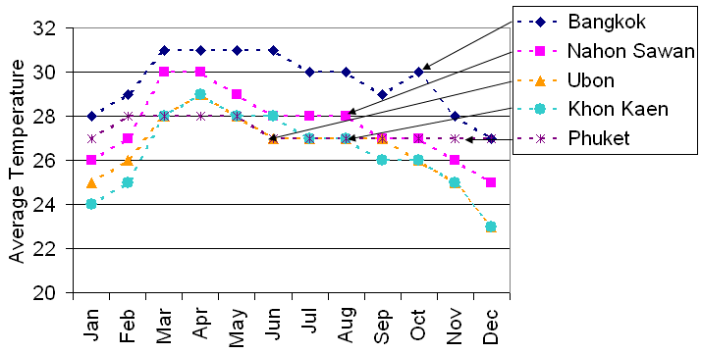
Figure 8(a) Average monthly temperature.
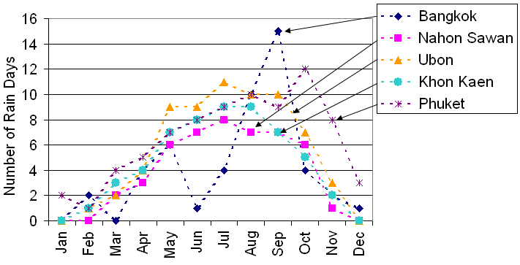
Figure 8(b) Average monthly days with rain.
Figure 8. Climate data for several cities in Thailand
[http://www.climate-zone.com/climate/thailand/, 2007].

The conclusion of this section is that everyone, including climate scientists, must be very careful about equipment, procedures, and protocols. It can be difficult to draw conclusions about climate changes even when those conclusions are based on data from sources that should be reliable.

3. What Kinds of Climate Change Research Can Students Do?

There are many areas of Earth science that can benefit from student measurements, but I will focus just on measurements related to interactions of the sun with Earth and its atmosphere. This is an important topic in any Earth science course, and is usually introduced through an image such as shown in Figure 9. This figure shows how the Earth maintains “radiative balance” with incoming solar radiation, as required by basic physical laws. Incoming solar radiation is absorbed by the atmosphere, land, and water, and some of that radiation is scattered and reflected back to space. Absorbed radiation is re-emitted as longwave thermal radiation from Earth’s surface and atmosphere.

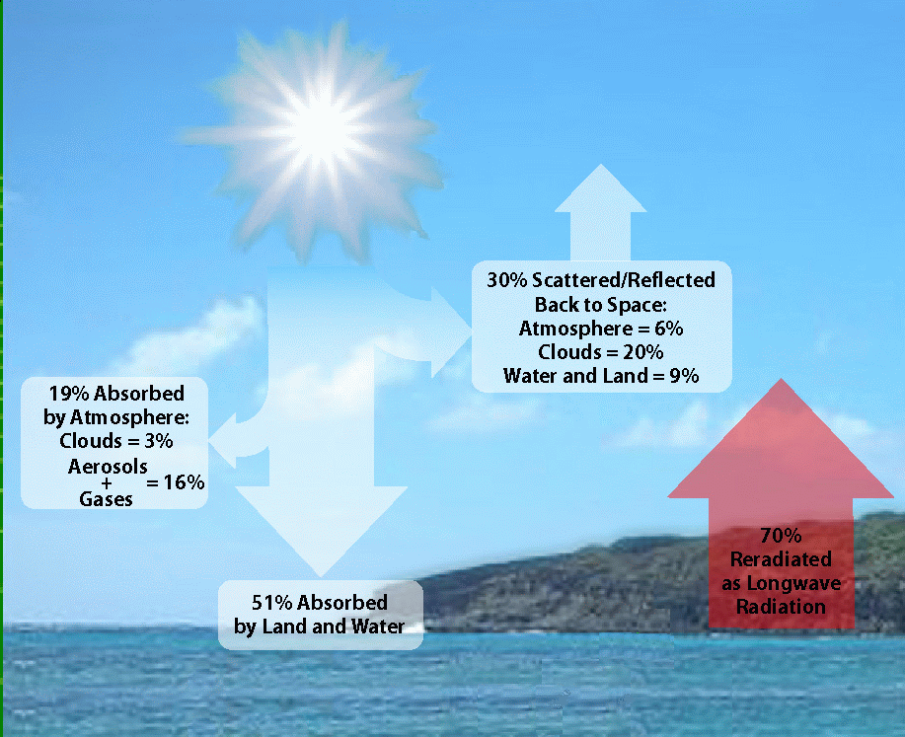
Figure 9. Earth’s Radiative Balance. [Image created by Vivek Dwivedi, NASA Goddard Space Flight Center.]

There is a great deal of science embedded in this image, which is difficult for students (and adults!) to understand. The best way for students to begin appreciating the complexity of these interactions is by making their own observations and measurements, as described below.

Sky Photography
Carefully planned photographs of the sky are very valuable for documenting, and even quantifying, climate changes when they are taken over an extended period of time. Figure 10 shows an image of the sun and its aureole taken at my home on a very clear autumn day. The aureole is the circular region of light-colored sky around the sun. It is caused by scattering from dust and other aerosols in the atmosphere. A very clear sky produces a small aureole, and a very “dirty” sky can produce a very large aureole. Hence, the size of the solar aureole is related to aerosol optical thickness.

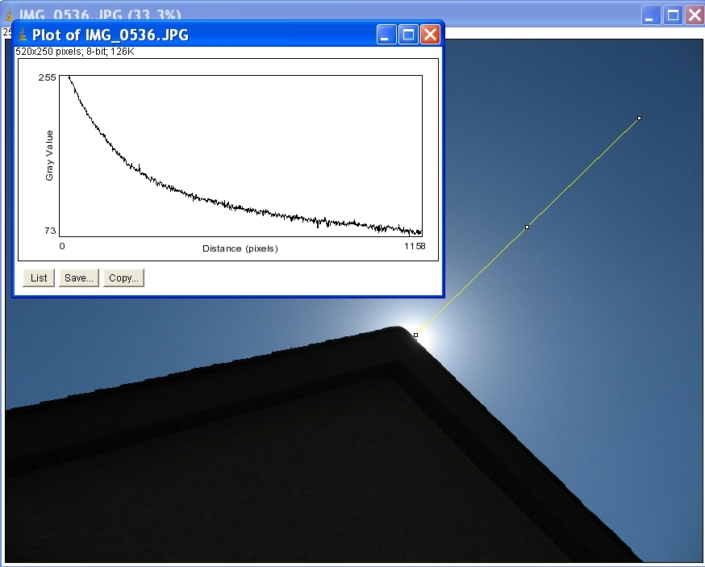
Figure 10. Solar aureole on a very clear day in Pennsylvania, October, 2007. Canon PowerShot A530, f-5.6 @ 1/1600 s.

With digital photography it is very easy to analyze digital images of the aureole, as has been done in Figure 10. The graph of intensity as a function of distance from the middle of the solar disk was generated by ImageJ, a free image analysis program available from the U.S. National Institutes of Health at http://rsb.info.nih.gov/ij/download.html. This image was taken on a very clear day, so the aureole is small and the sky brightness decreases exponentially as a function of distance from the sun. This kind of analysis of aureole photos of different sky conditions always taken with the same f-stop and exposure time should be strongly correlated with aerosol optical thickness.
Aureole photographs are very interesting and useful. However, it is important to take precautions! The CCD (charge-coupled device) used to capture images in a modern digital camera, with an LCD screen for composing your photo, is the equivalent of a camera shutter that is always open whenever your camera is on. If you point your camera directly at the sun without blocking as much of the solar disk as possible, it is very possible that intense light from the sun will permanently damage the CCD.
A much safer and equally interesting target for photography is the sky above the horizon. Figure 11 shows two sky photos from Texas, in the southwest part of the United States. The photos are taken looking north at solar noon. The left-hand image shows a very polluted sky and the right-hand image shows a very clear sky one week later. The relative brightness above the horizon is obtained from ImageJ’s analysis tools. These photos were not taken with the same f-stop and exposure, so the absolute brightness levels cannot be compared. But, the images still show dramatic differences between these two sky conditions. The “noise” in the two graphs is due to “pixelation” in the image that is not readily apparent to the eye. The exponential decrease in brightness as a function of distance above the horizon is typical for a very clear sky, dominated by molecular (Rayleigh) scattering by gas molecules in the atmosphere. The much different appearance of a very polluted sky results from absorption and scattering by a high density of particulates (aerosols) suspended in the atmosphere.

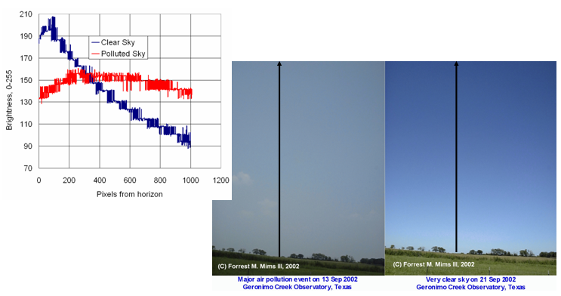
Figure 11. Analyzing solar noon skies [photos courtesy of Forrest Mims, 2007].

For climate science, we must ask what differentiates casual photography from images that have scientific value. Here are some guidelines:

1. Always use the same digital camera—one with manual control over focus, f-stop, and exposure. Even with two “good” cameras, images will look different because different cameras do not process light the same.

2. Always use the same f-stop and exposure settings for the same scene, regardless of the lighting conditions. Never use automatic settings, because your camera will try to “fix” scenes that its algorithms believe are going to be under- or over-exposed. Manually focus on infinity.

3. Use the highest resolution your camera supports. Do not resize or compress images, and do not apply any digital enhancements.

4. Once you have selected a scene—the sky at solar noon, for example—photograph that scene always at the same time of day, from the same place.

5. Keep careful records about scenes, dates, times, and location, including latitude, longitude, and elevation.

6. For photography, as for other measurements, consistent, long-term records are critical for observing persistent changes in the atmosphere.

Pyranometry
The basic measurement of interest for understanding the interactions of the sun with Earth and its atmosphere is insolation—solar energy falling on a horizontal plane at Earth’s surface. This quantity is measured with a pyranometer. Research-quality pyranometers can cost thousands of dollars, but for only a few dollars it is possible to build a very reliable pyranometer, developed by the author, that uses a small solar cell as a sunlight detector. When properly calibrated against a commercial pyranometer—some cost less than $200—you can collect insolation data that will teach students a lot about weather and climate and will have significant scientific value.
The upper photo in Figure 12 shows two 5th grade students pointing to a data logger inside their schools’ Stevenson screen and to a pyranometer installed on the roof of the shelter. The lower photo shows another of the author’s pyranometers next to a commercial pyranometer from Apogee Instruments, Inc. These instruments are mounted on this school’s roof and are used as a reference and calibration standard. The graph shows insolation, air temperature, and relative humidity during a week in May, 2007, recorded at one-minute intervals. The blue data are for a second pyranometer that was being calibrated at the time. There are not many sources of pyranometer data recorded at one-minute intervals, but several schools in the U.S. are now reporting these data.
Even without an instrument with high absolute radiometric accuracy, these data can be used to generate quantitative statistics about the variability of cloud amount and cloud type. Because cloud patterns influence and are affected by climate, changes in cloud patterns are important indicators of climate change.

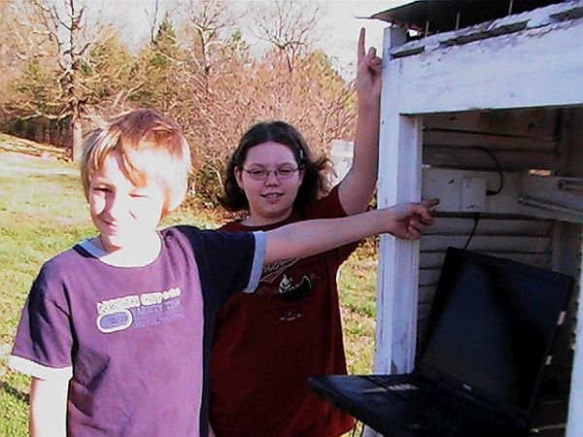 | 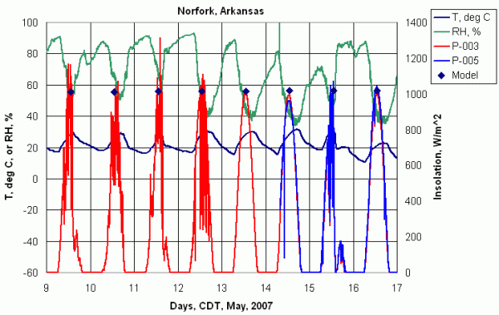
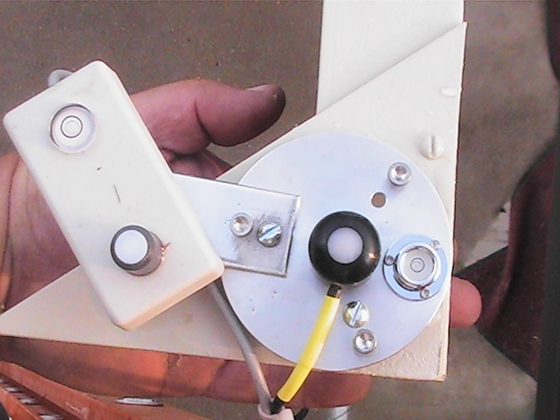
Figure 12. Student pyranometer data from a rural elementary school in Arkansas [Photos courtesy of Wade Geery].

Figure 13 shows how three days—a very clear day, a partly cloudy day, and an overcast day with precipitation at a high school in Texas—are analyzed to show cloud patterns. One-minute insolation values are averaged over an hour and “normalized” relative to a value of insolation that is larger than would ever actually be observed (1400 W/m²). Then the standard deviation of these normalized values is calculated. For a very clear day, the insolation values are very nearly equal to the modeled normalized values and the standard deviations are very small. On an overcast day, the means are smaller and the standard deviations are lower than for a partly cloudy day. When many days are analyzed like this, the resulting patterns provide a visual description of cloud patterns that may change over time. There will be significant seasonal differences, certainly in monsoon-dominated climates, and perhaps more subtle long-term changes that result from climate changes.

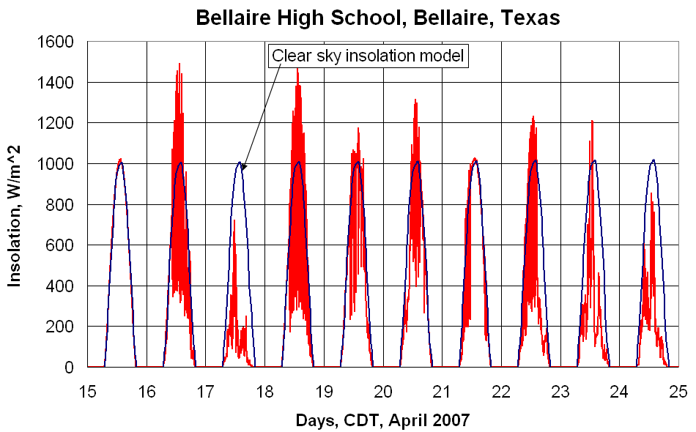
Figure 13(a) Insolation data from a high school in Texas.
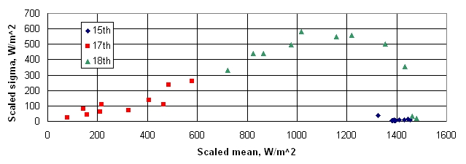
Figure 13(b) Statistical analysis of normalized insolation values for clear, partly cloudy, and overcast/precipitating days.
Figure 13. Using pyranometer data to generate cloud statistics.

Surface Reflectivity
The pyranometer discussed above is so inexpensive that is reasonable to build a “reflectometer” consisting of two pyranometer detectors mounted on a long pole or piece of hollow aluminum tubing. With one detector pointed up and the other straight down at the ground, you can easily measure the reflectivity of the surface. Figure 14 shows some simple measurements made at my house, walking first across a flagstone patio, then across a gravel driveway, onto a grass lawn, and back again. The instrument I used has a total of four detectors—two broadband detectors and two physically identical detectors that respond only to the near-infrared part of the solar spectrum. The differences in reflectivity among these three surface are clearly evident, and are much larger over grass in the near-IR. Such measurements are of interest to climate change science because reflectivity values change with the seasons and soil moisture.
Because reflectivity measurements depend only on the ratio of incident to reflected sunlight, it is not necessary to provide an absolute radiometric calibration—a relative calibration of one instrument against the other is all that is required. This means that reflectometers can be built by students and used even when no reference pyranometer standard is available.

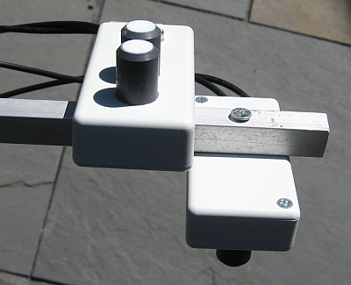 | 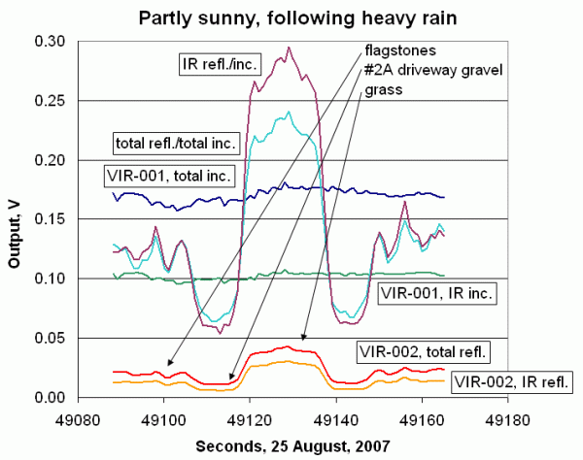
Figure 14. Reflectivity measurements made over three different surfaces, August, 2007.

UV-A Radiometry
A pyranometer should measure all solar radiation incident on Earth’s surface. It is also of great interest to measure just selected subsets of the total insolation. Figure 15 shows a radiometer, developed by the author, that measures radiation in the UV-A part of the solar spectrum. It uses an LED with a sharp response peak around 372 nm. (The violet part of the visible spectrum starts at about 400 nm.) This measurement is of interest to scientists for certain kinds of validation measurements needed to interpret data from Earth-viewing spacecraft. Smoke in the atmosphere (from biomass burning, for example) disproportionately reduces UV reaching Earth’s surface and changing the UV radiation environment can disrupt certain ecosystems. Mosquitoes are sensitive to UV radiation levels and reductions in UV may be associated with the spread of bird flu [Mims, 2005].

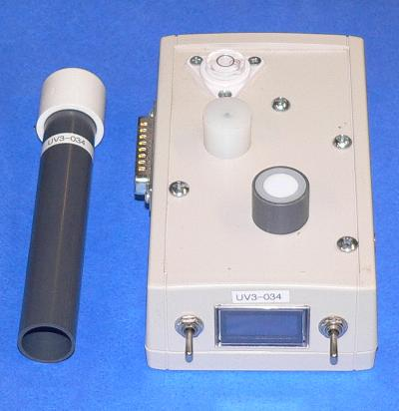 | 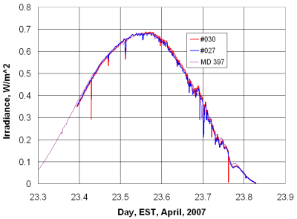
Figure 15. UV-A radiometer and two instruments calibrated against a reference UV radiometer, Greenbelt, Maryland, April, 2007.

The calibration of two of these UV-A radiometers against a reference UV standard is shown in the graph in Figure 15. The occasional downward “spikes” in the UV-A data are due to the fact that these instruments record instantaneous values and can respond even to small clouds passing over the sun, while the reference instrument averages many measurements over three-minute intervals.
The radiometer can also be used with a collimating tube to measure direct solar radiation at 372 nm and, if calibrated appropriately, aerosol optical thickness at this wavelength. (See the next section.) The ratio of direct to diffuse radiation is an important indicator of sky conditions, and these measurements are being made hardly anywhere in the world.

Sun Photometry to Monitor Atmospheric Aerosols and Water Vapor
Hundreds of inexpensive sun photometers using LEDs as selective light detectors, developed by the author and his colleagues [Brooks and Mims, 2001], are being used around the world to measure absorption and scattering of sunlight by particles in the atmosphere (aerosols). Sun photometers measure light coming directly from the sun to measure what is called “optical thickness.” Clear skies have low aerosol optical thickness, but dust, smoke, and other forms of air pollution will increase aerosol concentrations. The effects of aerosols on Earth’s surface temperature is one of the largest uncertainties in computer models used to predict future climate. There are several hundred “professional” sun photometers around the world, including a few in southeast Asia. However, aerosols vary considerably across small regional and even local spatial scales, so many more measurements of aerosol optical thickness (AOT) are needed to help scientists correlate ground-based and space-based measurements of aerosols around the globe. Data from these handheld sun photometers have been used in publications in the peer-reviewed science literature [Boorsma and de Vroom, 2006; Brooks and Mims, 2001] and can play an important role in monitoring aerosols.
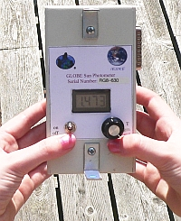
Figure 16. Two-channel visible light sun photometer.
Figure 17 shows some AOT data collected by a rural school in Arkansas (the same school that produced the pyranometer data shown in Figure 12). At this school, data quality control is provided by using several sun photometers—only two are shown here. This data record suffers from a common problem—very little data are collected during the summer, when schools are closed and AOT values tend to be the highest.

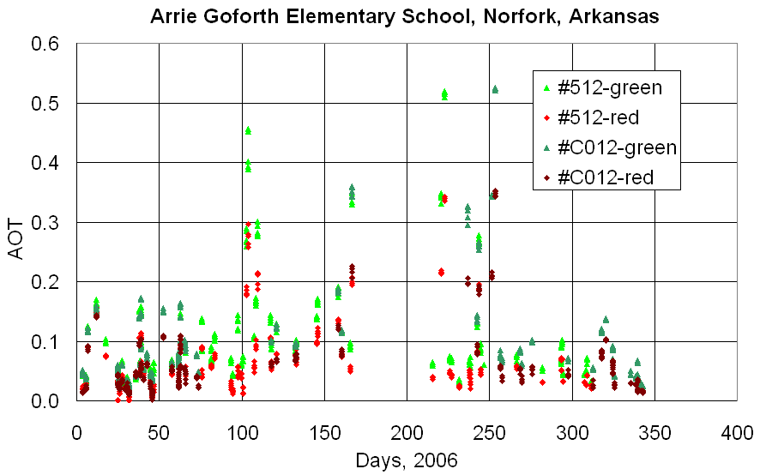
Figure 17. Aerosol optical thickness data (AOT) from two sun photometers at a rural school in Arkansas.

Figure 18. shows AOT data from a school in Puerto Rico. In this case, a nearby sun photometer from the Aerosol Robotic Network (AERONET) provides comparison data. There is generally good agreement between the two-channel handheld sun photometer and AERONET but there are, again, summer gaps in the student data record. Especially during the summer, there are many questions about the algorithms used to process AERONET data. At an AOT value of 2, the sun is so dim that it appears as a pale reddish disk and it is perfectly safe to look directly at it. Some of the values shown here may be contaminated with clouds between the instrument and the sun. It is also possible that the higher AOT values represent legitimate results due to high levels of dust in the atmosphere, Dust from the Sahara desert often blows eastward across the Atlantic Ocean to the Caribbean and southern United States. Sky photographs, as described earlier, would help to interpret these data.
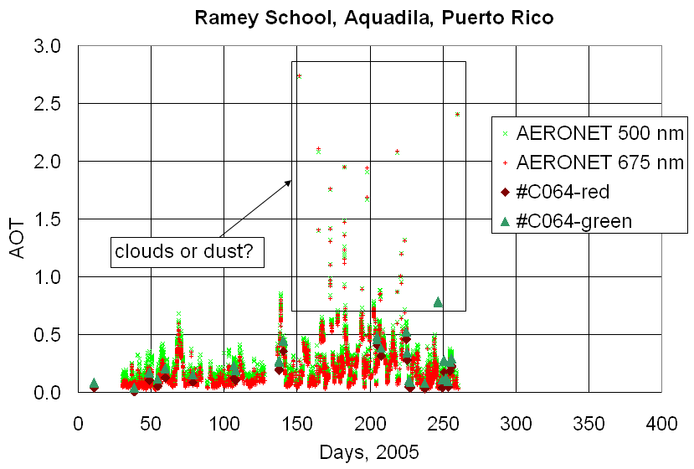
Figure 18. Aerosol optical thickness from Puerto Rico, including AERONET data.

A physically identical handheld sun photometer with near-IR detectors can be used to measure total atmospheric water vapor by comparing the output from two detectors. One detector responds to radiation in a water vapor absorption band and the other responds to radiation at nearby wavelengths where there is no water vapor absorption. Water vapor varies significantly around the globe and there are few reliable sources of ground-based data. Figure 19 shows one such site in Puerto Rico. It shows data from a handheld near-IR sun photometer and a nearby “GPS-MET” site that uses signals from global positioning satellites to measure water vapor. There are about 100 GPS-MET sites in the United States and the Caribbean, but very few in the rest of the world. As shown in the figure, water vapor data from this school agree very well with the GPS-MET data and provided data during 2005 when the GPS-MET site was shut down.

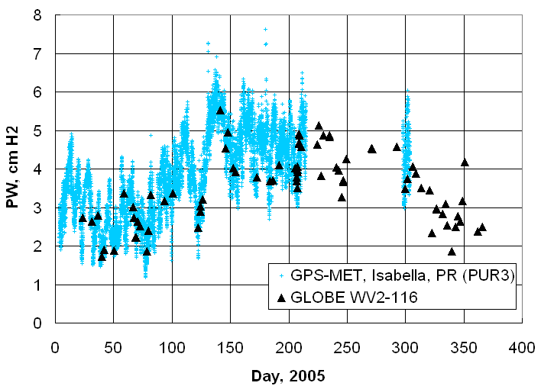
Figure 19. Water vapor measurements from Puerto Rico, with GPS-MET system and near-IR handheld sun photometer data.

Air and Soil Temperature
If you think that there are already more than enough air temperature measurements available around the world, think again! Reliable records of air temperatures taken simultaneously with soil temperatures are very hard to find. Figure 20 shows air and soil temperatures from a school in Pennsylvania, near where I live. These data are typical for a temperate climate. (However, the summer maximum temperatures are probably a little high because the thermometer was not in a standard enclosure.) Air temperatures vary over a wide range, but soil temperatures vary more slowly, with higher minimum temperatures and lower maximums. In this figure, the data show that, starting in December, 2000, the soil temperatures were nearly constant (at about 6-7°C) for several weeks. This is because of snow cover, which insulates the soil from changes in air temperature.
Simultaneous air and soil temperature data are extremely valuable for agriculture and pest management programs. Soil moisture and air and soil temperature are related, and it is much less expensive to monitor soil temperature on a regular basis than soil moisture. Changes in soil temperature can be important indicators of climate change. In Arctic regions, regional climate warming is reflected in rising soil temperatures, including melting of the permafrost layer. In tropical climates with a smaller range of air temperatures, changes in soil temperatures may be more closely related to changing precipitation patterns. Soil temperature may also be related to the insolation measurements discussed earlier.

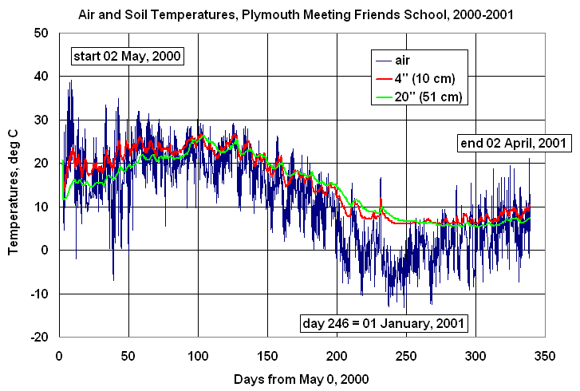
Figure 20. Simultaneous air and soil temperatures in suburban Pennsylvania, 2000-2001.

4. Discussion

The examples given here demonstrate that, just within the general area of atmospheric science, there are many opportunities for meaningful student/teacher/scientist partnerships that can produce valuable data for studying climate change. Collaboration with scientists is essential. Teachers and school administrators should not be expected to provide the expertise needed to define appropriate and productive research questions and protocols on their own. On the other hand, scientists should not be expected to understand how to provide the best educational experience for students or how to meet the needs of teachers.
Opportunities for meaningful student research arise basically from the fact that Earth and climate science depend heavily on having many sources of reliable long-term data. The fact that schools tend to provide stable physical environments makes them ideal places to conduct long-term climate research. However, because students graduate and teachers move on, it is essential for schools to make institutional commitments that extend over years rather than months. Although the efforts of individuals can start such projects, institutions must take responsibility for their continuation. In the same way that major science initiatives in the United States, supported by NASA and others, set aside some funding for educational outreach activities, educational institutions must be willing to support authentic research that goes beyond what is required just to support high-quality science education.
Are these commitments worth the effort? This is a question that must be answered by countries, school administrators, teachers, and students. But, clearly, my own answer is, “Yes!” I believe not only that students can make valuable contributions to climate science research, but that they must be given opportunities to do so. This may require a radical redefinition of science education from learning about science to learning how to do science. But, during the 21st century, Earth’s inhabitants will face significant climate change and they will need to deal with its consequences, both technologically and politically. Meeting these challenges will require the application of every bit of political will and technological skill we can develop. Today’s students are the only source of the leadership that will be required, and we cannot afford to delay giving them the information and tools they need to become active participants.

5. References

Boersma, K.F., and J.P. de Vroom. "Validation of MODIS Aerosol Observations over the Netherlands with GLOBE Student Participation." Journal of Geophysical Research, Vol. III, p. D20311, doi. 10.1029/2006

Brooks, David R., Forrest M. Mims III, Rochard Roettger, Inexpensive Near-IR Sun Photometer for Measuring Total Column Water Vapor, Journal of Atmospheric and Oceanic Technology, 24, 1268-1276, 2007.

Brooks, David R., Forrest M. Mims III, Arlene S. Levine, Dwayne Hinton, The GLOBE/GIFTS Water Vapor Monitoring Project:An Educator's Guide with Activities in Earth Sciences. NASA Publication EG-2003-12-06-LARC, 2003.

Brooks, David. R., and Forrest M. Mims III. Development of an inexpensive handheld LED-based Sun photometer for the GLOBE program. Journal of Geophysical Research, 106, D5, 4733-4740, 2002.

Heinlein, Robert, Time Enough for Love, Ace Books, 1973, ISBN 0-7394-1944-7.

Northern Territory University, Australia (author unknown). Online at
http://www.cs.ntu.edu.au/homepages/jmitroy/sid101/uncc/fs-index.html

Mims, Forrest M. III., Avian Influenza and UV-B Blocked by Biomass Smoke,
Environmental Health Perspectives, 113, 12, 806-807, December 2005.

National Snow and Ice Data Center, 2007. Online at http://www.nsidc.org/news/press/2007_seaiceminimum/20070810_index.html.

Petit, J.R., et al., Climate and atmospheric history of the past 420,000 years from the Vostok ice core, Antarctica. Nature, 399, 429-436, 1999.

Rohde, Robert A., from publicly available data, for the Global Warming Art Project, 2007. [http://www.globalwarmingart.com/]

